07 Exercises

_________________________________________________________________

The following tables form part of a database held in a relational DBMS:

Hotel (hotelNo, hotelName, city)

Room (roomNo, hotelNo, type, price)

Booking (hotelNo, guestNo, dateFrom, dateTo, roomNo)

Guest (guestNo, guestName, guestAddress)

Where Hotel contains hotel details and hotelNo is the primary key;

Room contains room details for each hotel and (roomNo, hotelNo) forms the primary key;

Booking contains details of bookings and (hotelNo, guestNo, dateFrom) forms the primary key;

Guest contains guest details and guestNo is the primary key.

Write your answers from 3.8 - 3.10 in a text/word file and push it to Github. When you are finished with exercise 3.11 make a sql dump of the database and push it to github. We will look at it in the next class.

_________________________________________________________________

Answers

# 3.8 Identify the foreign keys in this schema. Explain how the entity and referential integrity rules apply to these relations.

The foreign keys in:

- **room**: hotel_no

- **booking**: hotel_no, guest_no

**\* Entity integrity rule:**

- No attribute of the primary keys hotel_no, room_no, guest_no, date_from is allowed to be null.

**\* Referential integrity rule:**

- In the **room** table, hotel_no is the foreign key targeting the hotel_no attribute in the **hotel** table, which means it is not possible to create a **room** record with a hotel_no that does not exist in **hotel**. It is not possible to create a new **room** record with a null hotel_no due to the entity integrity rule which does not allow hotel_no in **room** to be null.

- Similarly, in the **booking** table, hotel_no and guest_no are foreign keys targeting **hotel** and **guest** tables so it is not possible to create a booking record with a non-existing hotel_no in **hotel** table or non-existing guest_no in **guest** table.

# 3.9 Produce some sample tables for these relations that observe the relational integrity rules. Suggest some general constraints that would be appropriate for this schema.

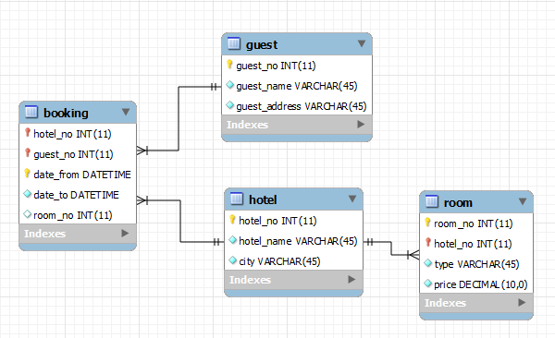

Some example general constraints:

* In **booking**: when updating or deleting a booking the constraints are set to CASCADE: meaning if a hotel or guest (parents relation) record is deleted/updated, all the booking (child) referencing to these hotel/guest records should be deleted or updated accordingly.
* In the exercise it says “Booking contains details of bookings and (hotelNo, guestNo, dateFrom) forms the primary key” but in reality it is not allowed to have 2 bookings with the same date_from, date_to and room_no (assuming that a double room booking is represented by 1 guest name); so it makes more sense to have date_from, date_to and room_no as composite keys.

# 3.10 Analyze the RDBMSs that you are currently using. Determine the support the system provides for primary keys, identity integrity, foreign keys, relational integrity.

* The current RDBMSs I am using is MySQL. MySQL is the world’s second most used open-source RDBMS. The official set of front-end tools is MySQL Workbench, developed by Oracle and is also free.
* MySQL Workbench supports database design and management with graphical user interface tools.

# 3.11 Implement the above schema in one of the RDBMSs you currently use. Implement, where possible, the primary, alternate and foreign keys, and appropriate relational integrity constraints.

- Created Schema called “hospitality”.